《赣南未来科技城战略规划与城市设计》
国际方案征集公告
Announcement on International Solicitation for
Strategic Planning and Urban Design of Gannan Future Science and Technology City

中国城市规划学会（承办方）受赣州市自然资源局（主办方）委托，面向国内外公开开展《赣南未来科技城战略规划与城市设计》国际方案征集活动（以下简称“本次征集活动”）。现将相关事项公告如下：
Urban Planning Society of China (the undertaker) is commissioned by Ganzhou Municipal Natural Resources Bureau (the organizer) to launch this open international solicitation activity for the Strategic Planning and Urban Design of Gannan Future Science and Technology City (hereinafter referred to as "this solicitation activity"). The relevant matters are hereby announced as follows.

- 征集背景
- Solicitation Background
赣州市位于赣江上游、江西省南部，是国家历史文化名城、江西省省域副中心城市、“一带一路”重要节点城市；是全国稀有金属产业基地、先进制造基地、江西省对接粤港澳大湾区的桥头堡城市。赣州市2021年政府报告中提出“以中科院赣江创新研究院为核心，高标准规划建设赣南未来科技城，把水东片区建成城市发展新地标”。
Ganzhou is located in the upper reaches of the Ganjiang River and in the south of Jiangxi Province. It is a national historical and cultural city, a provincial sub-centre in Jiangxi Province, and an important node of the Belt and Road Initiative. It is also a national rare metal industry base, an advanced manufacturing base, and a bridgehead city in Jiangxi Province that connects the Guangdong-Hong Kong-Macao Greater Bay Area. The Government Report 2021 of Ganzhou proposed that “to take the Ganjiang Innovation Research Institute of the Chinese Academy of Sciences as the core, to plan and construct the Gannan Future Science and Technology City with high-standards, and to turn the Shuidong area into a new landmark for urban development”.
赣南未来科技城规划建设旨在推进“中国稀金谷”建设，是打造江西省对接融入粤港澳大湾区桥头堡和构建新发展格局重要战略支点的重要路径，是赣州聚焦“科技创新、工业倍增升级、乡村振兴、新型城镇化、现代服务业、基础设施建设”六大主攻方向的现实要求，是推动赣州社会经济高质量发展的全新动能。
The planning and construction of the Gannan Future Science and Technology City aims to promote the construction of "China's Rare Mental Valley". It is an important path to build a bridgehead for Jiangxi Province to integrate into the Guangdong-Hong Kong-Macao Greater Bay Area and an important strategic node for building a new development pattern. It is the realistic requirement of Ganzhou to focus on the six main directions of "scientific and technological innovation, industrial multiplication and upgrading, rural revitalization, new urbanization, modern service industry, and infrastructure construction". It is a new driving force for the high-quality development of Ganzhou's society and economy.
规划好赣南未来科技城，要结合赣州中心城区产业发展基础、科技创新基础，挖掘赣南未来科技城区位、交通和自然生态格局等优势，破解土地收支平衡、用地空间紧张、生态敏感程度高等问题，将赣南未来科技城建设为具有国际影响力和竞争力的先进科技创新、先进产业延伸、先进城市生活的新标杆。
To plan the Gannan Future Science and Technology City, it is necessary to combine the industrial development foundation and technological innovation foundation of central Ganzhou, to explore the advantages of the location, transportation and natural ecological pattern of Gannan Future Science and Technology City, solve the problems of land balance, land-use space, and ecological sensitivity, to build Gannan Future Science and Technology City into a new benchmark for advanced technological innovation, advanced industrial extension, and advanced urban life with international influence and competitiveness
为广开思路，汲取先进的规划设计理念和发展策略，高标准规划建设好赣南未来科技城，特举行《赣南未来科技城战略规划与城市设计》国际方案征集活动。本着公开、公正、公平的原则，诚邀国内外具有卓越水平和丰富经验的设计机构参与，提供高质量和可操作的规划设计方案。
In order to broaden ideas, absorb advanced planning and design concepts and development strategies, to plan and build Gannan Future Science and Technology City with high standards, the International Solicitation for Strategic Planning and Urban Design of Gannan Future Science and Technology City is now held. Based on the principles of openness, justice, and fairness, we sincerely invite excellent domestic and foreign design institutions with rich experience to participate.

- 规划与设计范围
- Planning and Design Scope
赣南未来科技城选址于赣州市中心城区北部，东临武夷山脉、西邻赣州经开区、南接河套老城区。
The Gannan Future Science and Technology City is located in the northern part of central Ganzhou, bordering the Wuyi Mountains in the east, Ganzhou Economic Development Zone in the west, and Hetao Old Town in the south.
本次规划范围分为两个层次：
This solicitation activity is divided into two levels:
（1）战略规划范围：战略规划层面主要针对赣南未来科技城，重点围绕赣州科技创新的发展战略和空间战略，通过研究，提出通过科技创新实现城市发展的路径，对赣州高新区等产业平台在科技创新方面发挥好作用提出思路。战略规划范围以中科院赣江创新研究院所在区域为核心，纳入储潭组团、水东组团东河大桥以北、马祖岩区域，水西组团、水西产业基地，面积约50.57平方公里。
Strategic planning: For the Gannan Future Science and Technology City, focusing on the development strategy and space strategy of Ganzhou's scientific and technological innovation, to propose a path to realize urban development through scientific and technological innovation, and put forward ideas for industrial platforms such as Ganzhou High-tech Zone to play a good role in scientific and technological innovation. The strategic planning scope takes the area where the Ganjiang Innovation Research Institute of the Chinese Academy of Sciences is located as a core, including the Chutan Group, the north of the Donghe Bridge in the Shuidong Group, the Mayanzu area, the Shuixi Group, and the Shuixi Industrial Base, covering an area of about 50.57 square kilometres.
（2）城市设计范围：北至厦蓉高速，西临赣江，南接东河大桥，东邻赣县，面积约17.85平方公里。为体现城市设计功能布局完整性，加强与周边区域的景观风貌协调，应将赣南未来科技城整体区域纳入城市设计研究范围。（具体范围详见附图2）
Urban design: Extends to Xiamen-Chengdu Expressway in the north, Ganjiang River in the west, Donghe Bridge in the south, and Ganxian County in the east, covering an area of approximately 17.85 square kilometres. In order to reflect the integrity of the urban design function layout and strengthen the coordination with the surrounding landscape, the overall area of the Gannan Future Science and Technology City should be included in the scope of urban design research. (see figure 2 for details).

- 工作要求
- Requirements
在战略规划层面，结合赣州稀金产业发展现状及中科院赣江创新研究院发展定位，合理研判赣南未来科技城产业发展面临的机遇与挑战，提出符合赣州稀金产业实际发展的具体举措及实践路径。分析研究中科院赣江创新研究院、赣州北站等重大项目对城市及周边区域的辐射带动能力。结合赣南未来科技城现有优势，从城市发展战略角度明确赣南未来科技城的发展目标、总体定位、主要职能等内容。基于赣州中心城区自然山水格局特征，多角度研究水东片区建成城市发展新地标的具体方案。
At the strategic planning level, combining with the development status of Ganzhou's rare metal industry and the development positioning of the Ganjiang Innovation Research Institute of the Chinese Academy of Sciences, to rationally judge the opportunities and challenges faced by the industrial development of Gannan Future Science and Technology City, and propose specific measures and practice paths in line with the actual development of Ganzhou's rare metal industry. To study the driving ability of major projects such as the Ganjiang Innovation Research Institute of the Chinese Academy of Sciences and Ganzhou North Station to the city and surrounding areas. Combining the existing advantages of Gannan Future Science and Technology City, to clarify the development goals, overall positioning, and main functions of Gannan Future Science and Technology City from the perspective of urban development strategy. Based on the characteristics of the natural landscape pattern in central Ganzhou, to study the specific scheme for building a new landmark of urban development in Shuidong area from multiple angles.
在城市设计层面，细化赣南未来科技城功能定位与稀金产业等业态在空间上的落实。分析研究中科院赣江创新研究院、赣州北站等重大项目的建设规模。基于区域范围内的自然人文资源与景观，统筹考虑片区经济收支问题，合理确定开发强度，明确空间形态、空间组织和建筑风貌。提升城市形象，强化重要区域、重要节点和重要界面设计。基于赣州中心城区现状综合交通体系，提出道路交通优化方案。多角度论证研究土地开发收支平衡难题，并合理安排项目开发策略和开发建设时序，充分考虑项目运作实施的可行性。
At the urban design level, to refine the spatial implementation of the functional positioning and industrial formats such as rare metal of Gannan Future Science and Technology City. To study the construction scale of major projects such as the Ganjiang Innovation Research Institute of the Chinese Academy of Sciences and Ganzhou North Railway Station. Based on the natural and human resources and landscape within the area, to make overall consideration of the economic balance, rationally determine the development intensity, and clarify the spatial form, spatial organization and architectural style in the area. To enhance the image of the city and strengthen the design of important areas, important nodes and important interfaces. Based on the current comprehensive transportation system in central Ganzhou, to propose a road traffic optimization scheme. To study the problem of land development balance from multiple angles, and rationally arrange project development strategies and development and construction schedules, and fully consider the feasibility of project operation and implementation.

- 应征要求
- Application Requirements
（1）本次征集活动采用公开征集的方式，境内外合法注册且有与本项目类似的相关研究和设计经验的机构均可参加。其中：境内应征机构须具备规划甲级资质、建筑行业（建筑工程）甲级资质其中之一；境外应征机构须具有所在国、地区政府主管部门或其有关行业组织核发的从事战略咨询、城乡规划、建筑设计其中之一的相应资格或执业许可。本项目鼓励联合体报名，但联合体成员不得超过两家，联合体各方不得再单独以自己名义，或与另外应征机构组成联合体报名。
考虑到新冠疫情影响，境外应征机构（若在中国境内无分支机构）必须与境内应征机构组成联合体，境外应征机构联合境内应征机构的，境内应征机构资质要求同上。港澳台应征机构的资格要求参照境外应征机构资格要求的规定。不接受个人及个人组合的报名。法定代表人为同一个人的两个及两个以上法人、母公司、全资子公司及其控股公司，不得同时报名。
(1) This solicitation activity opens application to domestic and foreign institutions that are legally registered and have research and design experience similar to this project. The domestic applicant institutions must have one of Grade-A qualification of planning, or Grade-A qualification of architecture and construction engineering; foreign applicant institutions must have one of the relevant qualifications of strategy consulting, urban and rural planning, or architecture design issued by the competent authority or relevant industry organizations of their home country or region. This project encourages application by consortium, but the consortium shall not have more than two members, and the members of the consortium are not allowed to apply separately on their own or form another consortium.
Considering the impact of COVID-19, foreign applicant institutions (without branches in China) must form a consortium with domestic institutions. If a foreign applicant institution consorts with a domestic applicant institution, qualification requirements for the domestic institution are the same as above. The qualification requirements of Hong Kong, Macao and Taiwan institutions shall refer to the requirements of foreign applicant institutions. Applications by individuals or groups of individuals will not be accepted. For two or more legal entities whose legal representative is the same person, the parent company, the wholly-owned subsidiary and the holding company are not allowed to apply at the same time.
（2）参与本项目的专业技术人员须为该应征机构的在册人员，主创设计师须有主持过多个同类型项目经验，且主创设计师及团队成员须全过程参与本项目（项目发布会及现场踏勘、方案设计、方案汇报）。因为疫情原因，若境外主创设计师确不能到现场，需通过视频参加以上活动，并由境内主要设计师到场参加。项目团队需各专业工种配备齐全。为了保证项目团队人员对中国地区背景和相关要求的准确理解，境外应征机构的专业技术人员团队中应至少有一名通晓汉语人士。
(2) The professionals involved in this project must be the current registered staff of the applicant institution; the chief designer must have experience in directing several similar projects, and the chief designer and team members must participate in the whole process of the project (project release conference and site survey, scheme design, scheme reporting). Due to the epidemic situation, if the chief designer from abroad cannot participate in person, he or she must participate in the above activities via video, and the main domestic designers should be present to participate. The project team shall be fully equipped with all professional types of work. The professional team of the foreign applicant institution should include at least one member who is proficient in Chinese to ensure the accurate understanding of the regional background and relevant requirements.
（3）应征机构根据资格预审文件要求提供完整资格预审申请材料。
(3) The applicant institution shall provide complete prequalification application materials in accordance with the requirements of the Prequalification Document.
（4）除上述条款外，当本次征集活动主办方提出合理要求时，应征机构应继续补充提供符合相应要求的资格证明文件。
(4) In addition to the above terms, when the organizer of this solicitation activity raises reasonable requests, the applicant institution shall continue to provide supplementary certification documents that meet the corresponding requirements.

- 费用设置
- Fees and Awards
本次征集活动将通过资格预审评选出5家入围应征机构。入围应征机构按照《征集文件》要求递交有效应征文件后，经评审委员会评审确定方案排名。主办方将依据排名，支付第1名应征机构奖金280万元人民币（含税），支付第2名应征机构奖金200万元人民币（含税），支付第3名、第4名应征机构补偿金各150万元人民币（含税），支付第5名应征机构补偿金120万元人民币（含税）。
Five applicant institutions will be selected through the prequalification review. After the shortlisted applicant institutions submit valid application documents in accordance with the requirements of the Solicitation Document, the jury committee will review and determine the ranking of schemes. The organizer will pay the first applicant institution a bonus of RMB 2.8 million (including tax); pay the second applicant institution a bonus of RMB 2.0 million (including tax); pay the third and the fourth applicant institutions a compensation fee of RMB 1.5 million (including tax) each; pay the fifth applicant institution a compensation fee of RMB 1.2 million (including tax).
但对于未按规定时间提交应征文件，或其应征文件按《征集文件》规定不被接受，或被取消应征资格的应征机构，将不支付应征奖金及补偿金。
However, the applicant institution who fail to submit application documents within the prescribed time, or whose application documents are not acceptable according to the requirements of the Solicitation Document, or whose qualifications have been revoked, will not be paid the bonus or compensation fee.

- 时间计划
- Schedule
计划于2021年8月下旬确定入围应征机构、9月初召开项目发布会及组织现场踏勘，届时需应征机构主创设计师及设计团队参会。本次征集活动编制周期自项目发布会起约为80日历天（含节假日）。
It is planned to determine the shortlist of applicant institutions in late August 2021; to hold the project release conference and organize the site survey in early September. The chief designer and team members are required to participate. The scheme formulation period is about 80 calendar days from the project release conference (holidays included).

- 申请方式
- Application Method
凡有意参加本次征集活动的应征机构，需先进行申请登记，应征机构下载申请表格（附件1）并完整填写申请信息后，发送邮件至指定邮箱zxb@planning.org.cn，承办方收到申请表后，以邮件方式回复资格预审文件等相关文件。
Any applicant who intends to participate in this solicitation activity shall register first. After downloading the application form (Appendix 1) and completing the application information, the applicant shall send it to the designated email address zxb@planning.org.cn. After receiving the application form, the undertaker will reply with the Prequalification Document and other related documents by email.
资格预审申请文件需要严格按照相关要求制作，递交资格预审申请文件包括现场递交和快递邮寄两种方式。在疫情特殊情况下，以快递邮寄方式递交时，请预留足够的快递运输时间；现场递交需持法定代表人授权委托书。
Prequalification application documents shall be made in strict accordance with relevant requirements, and can be submitted by on-site submission or express delivery. Due to the special circumstances of the epidemic, if submit by express delivery, please reserve enough time for the express transportation; a letter of authorization by the legal representative shall be presented if submit on site.
递交资格预审申请文件的时间及地点：报名应征机构需于2021年8月23日16时前将资格预审申请文件的书面文件送达到下述指定地点，并将全部资格预审申请文件电子版发送至指定邮箱（zxb@planning.org.cn ）。资格预审申请文件书面文件递交地址：北京市海淀区三里河路9号住建部北配楼一层，中国城市规划学会，张工（收），010-58323854。接收资格预审申请文件时间为工作日09:00-16:00，逾期送交或不符合规定的资格预审申请文件恕不接受。如遇疫情管控等特殊情况，时间或地点变更将另行通知。
Submission time and place for the prequalification application documents: The applicant institutions should submit the printed prequalification application documents to the designated address before 16:00 on August 23, 2021, and send all electronic prequalification application documents to the designated email address (zxb@planning.org.cn). The submission address for the printed documents is as follows: Urban Planning Society of China, North Annex Building of Ministry of Housing and Urban-Rural Development, No.9 Sanlihe Road, Haidian District, Beijing, China, Miss Zhang (the addressee)， 010-58323854. The time for submission is 09:00-16:00 on working days. Prequalification application documents that are overdue or do not meet the requirements will not be accepted. In case of special circumstances such as pandemic control, the time or address will be notified.
资格预审结果公布：在资格预审申请文件递交截止日后30个日历天内公布入围应征机构评选结果。
Announcement of prequalification result: The selecting result of shortlisted applicant institutions will be announced within 30 calendar days after the deadline for submission of prequalification application documents.
联系方式：雷工010-58323868，张工010-58323854。
电话咨询时间：工作日上午09:00－11:00，下午14:00－16:00。
邮箱：zxb@planning.org.cn。
Contact: Miss Lei 010-58323868, Miss Zhang 010-58323854.
Telephone consultation time: 09:00-11:00 am, 14:00-16:00 pm on working days
Email: zxb@planning.org.cn

- 发布平台
- Announcement Platforms
本公告在中国城市规划网（www.planning.org.cn）、赣州市自然资源局（http://bnr.ganzhou.gov.cn/）、章贡区人民政府网（http://www.zgq.gov.cn/）同时发布。本公告的修改、补充以在上述网站媒体发布的内容为准。本公告中如有中、英文不一致之处，以中文为准。
The announcement is issued simultaneously on the website of Urban Planning Society of China (www.planning.org.cn), the website of Ganzhou Municipal Natural Resources Bureau (http://bnr.ganzhou.gov.cn/), and the website of Zhanggong District People's Government (http://www.zgq.gov.cn/). The amendments and supplements to this announcement are subject to the contents published on the above websites. If there is any inconsistency between Chinese and English in this announcement, the content in Chinese shall prevail.

2021年8月6日
August 6, 2021
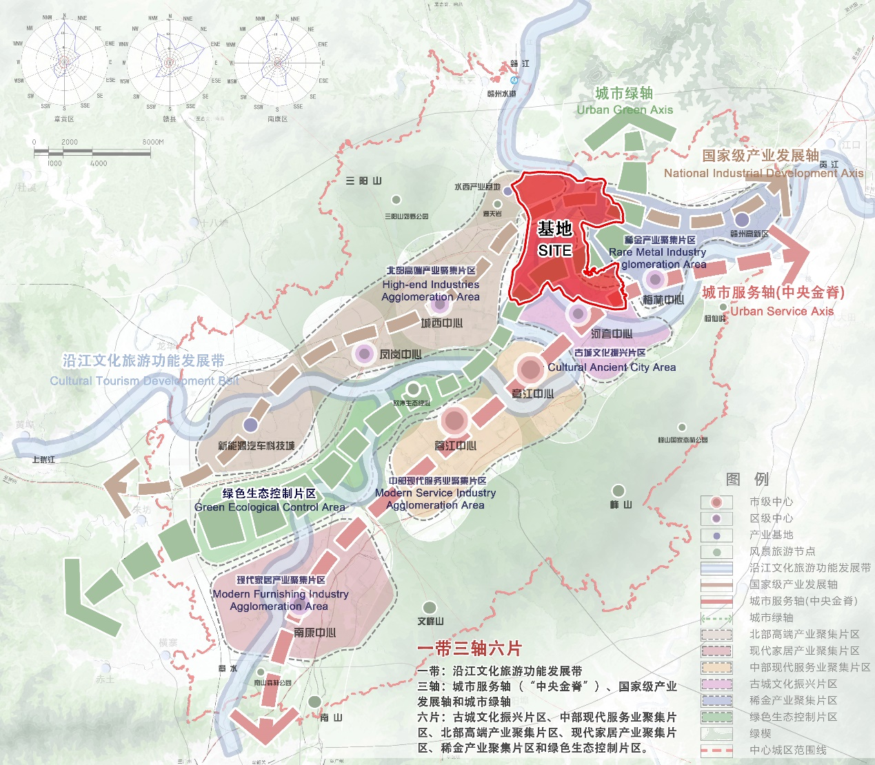
附图1 赣南未来科技城区位示意图
Figure 1. Location of Gannan Future Science and Technology City

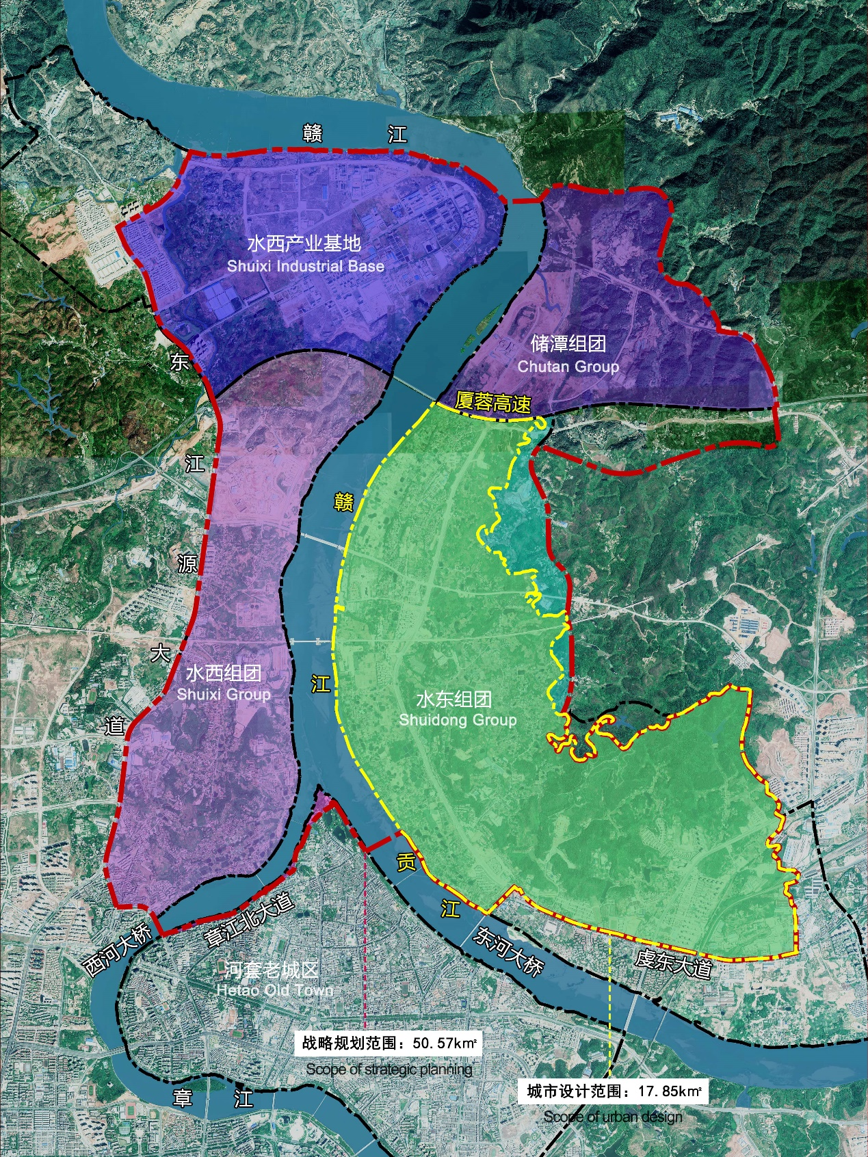
附图2 规划和设计范围示意图
Figure 2. Scope of Planning and Design

